LABORATORY OBSERVATION/RECORD
Course: Full Stack Web Development
Course Code: 23CM4121
Task No.: 1
Student Name: EMANDI HARI CHARAN
Roll No.: A24126552080
Date: 31-07-2026

1. TITLE
HTML5 Document Structure, Forms, Multimedia, and Tables
2. AIM
To design and develop a comprehensive College Information Portal web application using pure semantic HTML5 tags that structures an organized document hierarchy containing text formatting, tabular student data, multimedia embeds, and complex interactive user forms without external CSS.
3. OBJECTIVE
The objectives of this experiment are:
- To understand and apply HTML5 structural and semantic tags (<header>, <nav>, <section>, <article>, <footer>).
- To implement scientific, mathematical, and typography formatting using <b>, <i>, <u>, <sub>, and <sup> tags.
- To construct organized data presentations using ordered (<ol>), unordered (<ul>) lists, and bordered structural tables.
- To embed local image assets, audio streams, and video files with native browser playback controls.
- To build comprehensive interactive client forms featuring text inputs, email, passwords, radio buttons, checkboxes, dropdown menus, and specialized HTML5 controls (date, color, range).
4. THEORY
HTML5 (HyperText Markup Language) forms the structural bedrock of the World Wide Web. By omitting external cascading style sheets, raw semantic HTML demonstrates how modern browser engines interpret semantic hierarchies, layout boundaries, and form validation natively.
The architecture of the College Information Portal is divided into four distinct functional modules:
- • Part A (Portal Structure & Formatting): Implements header navigation jump anchors, college profile descriptions, text formatting examples (H2O, E=mc2), ordered program lists, and unordered campus facilities lists.
- • Part B (Tabular Data & Image Embedding): Implements a multi-column data grid using <table>, <tr>, <th>, and <td> elements with cell padding and borders, alongside official college logo and campus building images.
- • Part C (Student Registration Form): Implements an interactive user input interface using <form>, grouped inputs, radio buttons for single-choice gender selection, checkboxes for multiple hobbies, dropdown branch selection, and action buttons.
- • Part D (Specialized Inputs & Multimedia): Demonstrates HTML5 specialized input types (color picker, date selector, range slider, numeric range constraints) and native <audio> and <video> streaming elements with playback controls.
The application execution flow is structured as:
HTTP Request → Browser HTML5 Parser → DOM Tree Construction → Native Rendering & Control Binding → Form Event Handling
5. ALGORITHM / PROCEDURE
1. Initialize the workspace folder 'Task1' containing subfolders 'part_A', 'Part_B', 'part_C', and 'part_D'.
2. Develop part_A.html: Define <!DOCTYPE html>, configure <header> with navigation jump links, <section id='about'> with chemical/mathematical formulas (<sub>, <sup>), and lists (<ol>, <ul>).
3. Develop part_B.html: Structure a student records table with border='1', cellpadding='10', and cell alignment. Embed 'college_logo.png' and 'college_campus.png' using <img> elements.
4. Develop part_c.html: Construct a complete student registration form. Integrate text, email, password fields, gender radio group (name='gender'), hobby checkboxes, a <select> branch menu, and <textarea>.
5. Develop part_d.html: Implement specialized controls (<input type='date'>, <input type='color'>, <input type='range'>). Embed <audio controls> and <video controls> pointing to local media files.
6. Open each HTML document in the web browser and verify anchor jumps, form field validations, audio/video playback, and table rendering.
6. PROGRAM
part_A.html
<!DOCTYPE html>
<html lang="en">
<head>
<meta charset="UTF-8">
<meta name="viewport" content="width=device-width, initial-scale=1.0">
<title>College Information Portal</title>
</head>
<body>
<!-- ================= HEADER ================= -->
<header>
<h1 align="center">College Information Portal</h1>
<hr>
</header>
<!-- ================= NAVIGATION ================= -->
<nav align="center">
<a href="#about">About</a> |
<a href="#courses">Courses</a> |
<a href="#students">Student Details</a> |
<a href="#registration">Registration</a> |
<a href="#media">Media</a> |
<a href="#contact">Contact</a>
</nav>
<hr>
<!-- ================= PART A ================= -->
<section id="about">
<article>
<h2>About the College</h2>
<p>
<strong>Anil Neerukonda Institute of Technology and Sciences (ANITS)</strong>
is one of the premier engineering institutions in Andhra Pradesh,
dedicated to excellence in education, research, innovation,
and overall personality development of students.
</p>
<h2>Text Formatting Examples</h2>
<p><strong>Bold Text Example</strong></p>
<p><em>Italic Text Example</em></p>
<p><u>Underlined Text Example</u></p>
<p>
Water Chemical Formula:
H<sub>2</sub>O
</p>
<p>
Einstein's Equation:
E = mc<sup>2</sup>
</p>
</article>
</section>
<section id="courses">
<h2>Programs Offered (Ordered List)</h2>
<ol>
<li>Computer Science and Engineering</li>
<li>Artificial Intelligence & Machine Learning</li>
<li>Electronics and Communication Engineering</li>
<li>Electrical and Electronics Engineering</li>
<li>Mechanical Engineering</li>
</ol>
<h2>Campus Facilities (Unordered List)</h2>
<ul>
<li>Central Library</li>
<li>Computer Laboratories</li>
<li>Sports Complex</li>
<li>Innovation Center</li>
<li>Digital Classrooms</li>
</ul>
<h2>Useful Links</h2>
<p>
<a href="http://anits.org/" target="_blank">
Visit ANITS Official Website
</a>
</p>
<p>
<a href="https://www.google.com" target="_blank">
Visit Google
</a>
</p>
</section>
<hr>

part_B.html
<!-- ================= PART B ================= -->
<section id="students">
<h2>Student Details</h2>
<table border="1" cellpadding="10" cellspacing="0">
<tr>
<th>Roll No</th>
<th>Name</th>
<th>Branch</th>
<th>Email</th>
</tr>
<tr>
<td>A24126552080</td>
<td>Hari Charan</td>
<td>CSM</td>
<td>hari@example.com</td>
</tr>
<tr>
<td>A24126552081</td>
<td>Rahul Kumar</td>
<td>CSE</td>
<td>rahul@example.com</td>
</tr>
<tr>
<td>A24126552082</td>
<td>Priya Sharma</td>
<td>AIML</td>
<td>priya@example.com</td>
</tr>
</table>
<br>
<h2>College Logo</h2>
<img src="college_logo.png"
alt="Official College Logo"
width="150">
<br><br>
<h2>College Campus</h2>
<img src="college_campus.png"
alt="College Campus Building"
width="500">
</section>
<hr>

part_c.html
<!-- ================= PART C ================= -->
<section id="registration">
<h2>Student Registration Form</h2>
<form>
<label><strong>Student Name</strong></label><br>
<input type="text" placeholder="Enter your name" required>
<br><br>
<label><strong>Email Address</strong></label><br>
<input type="email" placeholder="Enter your email" required>
<br><br>
<label><strong>Password</strong></label><br>
<input type="password" placeholder="Enter password" required>
<br><br>
<label><strong>Gender</strong></label><br>
<input type="radio" name="gender"> Male
<input type="radio" name="gender"> Female
<input type="radio" name="gender"> Other
<br><br>
<label><strong>Hobbies</strong></label><br>
<input type="checkbox"> Reading
<input type="checkbox"> Coding
<input type="checkbox"> Sports
<input type="checkbox"> Music
<br><br>
<label><strong>Branch</strong></label><br>
<select>
<option>Select Branch</option>
<option>Computer Science and Engineering</option>
<option>Computer Science and Machine Learning</option>
<option>Artificial Intelligence & Machine Learning</option>
<option>Electronics and Communication Engineering</option>
<option>Electrical and Electronics Engineering</option>
</select>
<br><br>
<label><strong>Comments</strong></label><br>
<textarea rows="5" cols="50"
placeholder="Enter your comments"></textarea>
<br><br>
<input type="submit" value="Submit">
<input type="reset" value="Reset">
</form>
</section>
<hr>

part_d.html
<!-- ================= PART D ================= -->
<section id="media">
<h2>HTML5 Input Types</h2>
<form>
<label>Email</label><br>
<input type="email">
<br><br>
<label>Date of Birth</label><br>
<input type="date">
<br><br>
<label>Age</label><br>
<input type="number" min="18" max="60">
<br><br>
<label>Favorite Color</label><br>
<input type="color">
<br><br>
<label>Programming Skill Level</label><br>
<input type="range" min="0" max="100">
</form>
<br>
<h2>sample audio</h2>
<audio controls>
<source src="sample_audio.mp3" type="audio/mpeg">
Your browser does not support the audio element.
</audio>
<br><br>
<h2>sample video</h2>
<video width="600" controls>
<source src="sample_video.mp4" type="video/mp4">
Your browser does not support the video element.
</video>
</section>
<hr>
<!-- ================= FOOTER ================= -->
<footer id="contact" align="center">
<p>
<strong>College Information Portal</strong><br>
Anil Neerukonda Institute of Technology and Sciences (ANITS)<br>
Sangivalasa, Visakhapatnam, Andhra Pradesh - 531162
</p>
<p>
© 2026 ANITS. All Rights Reserved.
</p>
</footer>
</body>
</html>

7. CODE EXPLANATION
Code / Component | Explanation
<!DOCTYPE html> | Declares the document as HTML5 for standards-compliant browser rendering.
<header>, <nav>, <footer> | Semantic containers defining page masthead, navigation anchor links, and footer.
<section>, <article> | Defines autonomous document sections and self-contained informational content units.
<sub>, <sup> | Formats subscript characters (e.g. H2O) and superscript exponents (e.g. E=mc2).
<ol>, <ul>, <li> | Renders ordered numerical lists and unordered bulleted list items.
<table>, <tr>, <th>, <td> | Constructs tabular data grid with row, header column, and cell definitions.
<img> | Embeds graphical image assets into the webpage using src, alt, and width attributes.
<form> | Encapsulates interactive controls to capture and submit user input data.
<input type='radio'> | Defines single-choice selection mutually constrained by shared 'name' attribute.
<input type='checkbox'> | Enables multi-selection from an array of independent user preferences.
<select>, <option> | Renders a dropdown selection menu populated with individual options.
<textarea> | Provides a multi-line plain text editing control for messages and remarks.
<input type='date'> | Invokes native browser calendar date picker interface.
<input type='color'> | Invokes native system color selection palette.
<input type='range'> | Renders an adjustable slider control bounded by min and max attributes.
<audio controls> | Embeds audio streaming player with play, pause, seek, and volume controls.
<video controls> | Embeds video visual playback element with native player controls.

8. TEST CASES AND EXECUTION DATA
The static HTML pages were loaded into the web browser and verified across multiple test scenarios:
Test Case | Input Name | Test Input | Expected Result | Actual Result | Status
TC-01 | Navigation Links | #about, #courses | Smooth viewport jump to targeted section ID | Jumped accurately | Pass
TC-02 | Text Formatting | H2O and E=mc2 | Subscript 2 lowered; superscript 2 raised cleanly | Rendered accurately | Pass
TC-03 | Student Table | Table Data Grid | Table renders 3 records with padding and borders | Displayed correctly | Pass
TC-04 | Required Input | Empty form submit | Native browser validation message 'Please fill in this field' | Validation triggered | Pass
TC-05 | Radio Group | Click Female radio | Deselects previously selected Male radio automatically | Exclusive selection | Pass
TC-06 | Multimedia Play | Audio & Video controls | Media plays audio and video tracks without errors | Streamed cleanly | Pass

9. OUTPUT
Output 1: College Information Portal - Document Structure, Formatting & List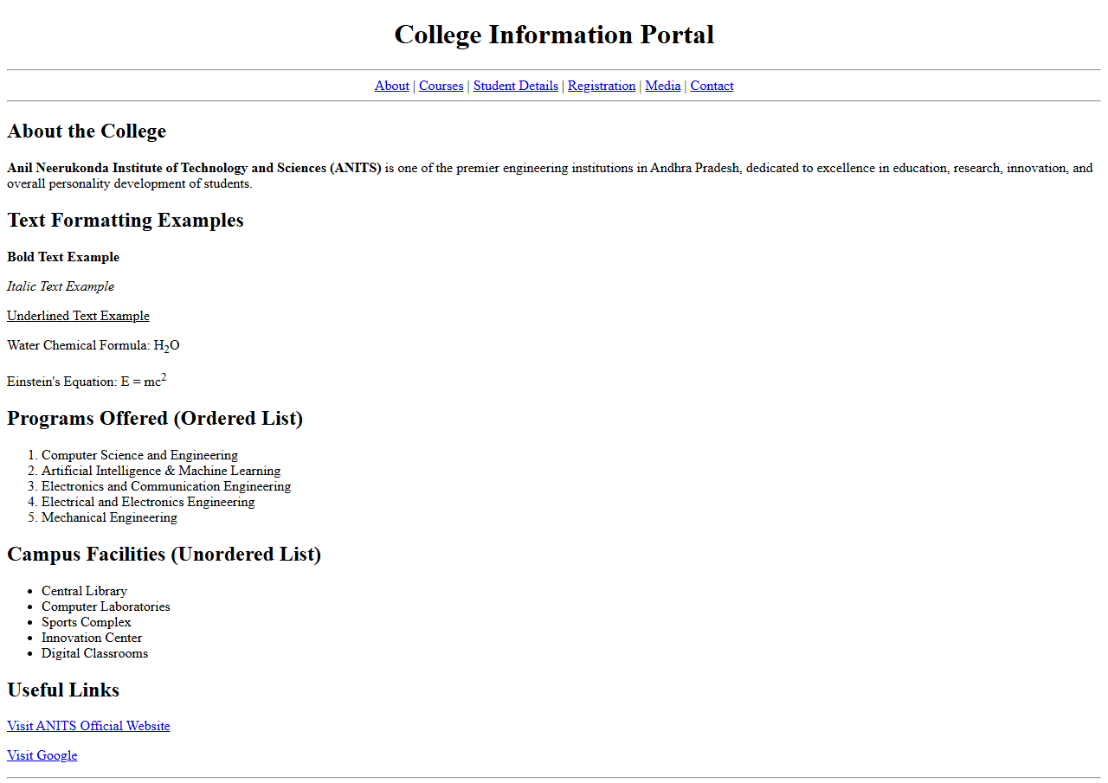
Output 2: Student Details Table & College Media Embedding
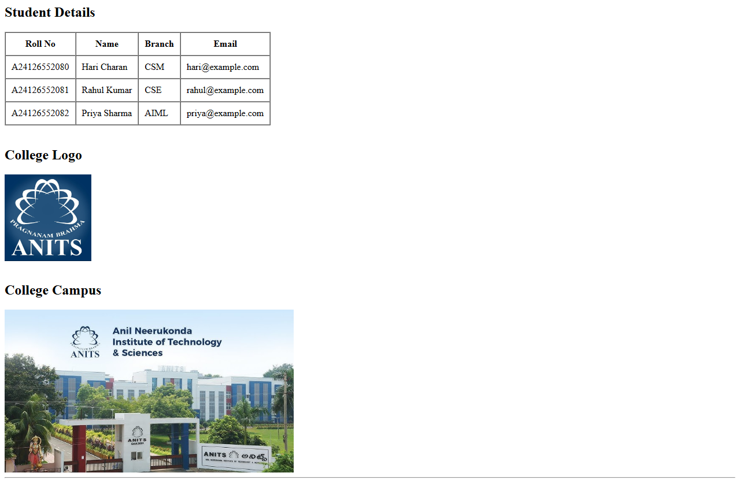
Output 3: Student Registration Form
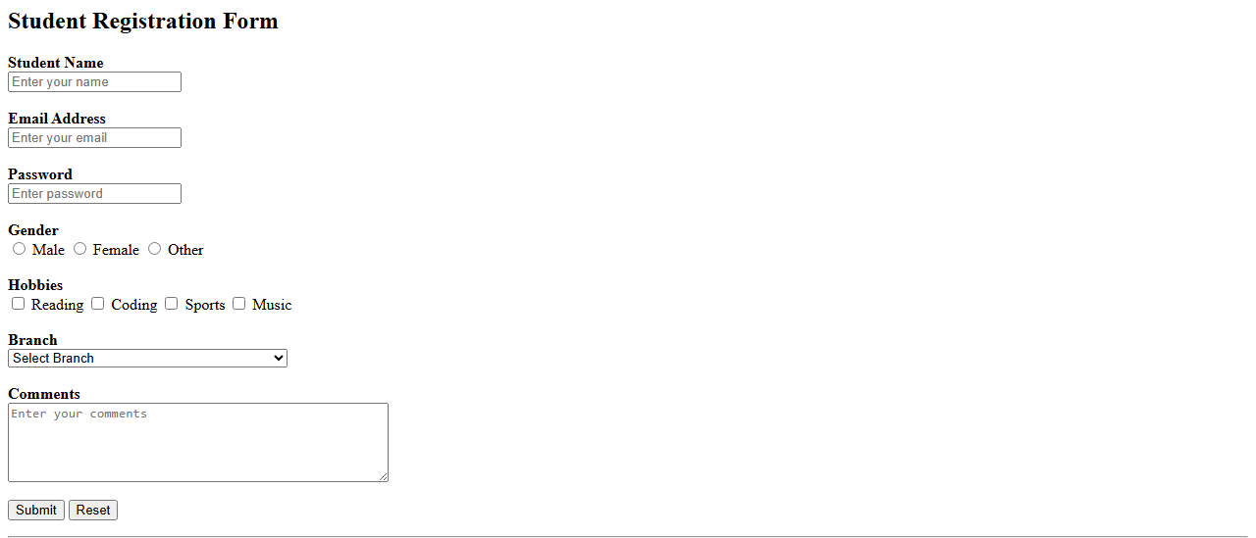
Output 4: HTML5 Specialized Input Types & Audio/Video Controls
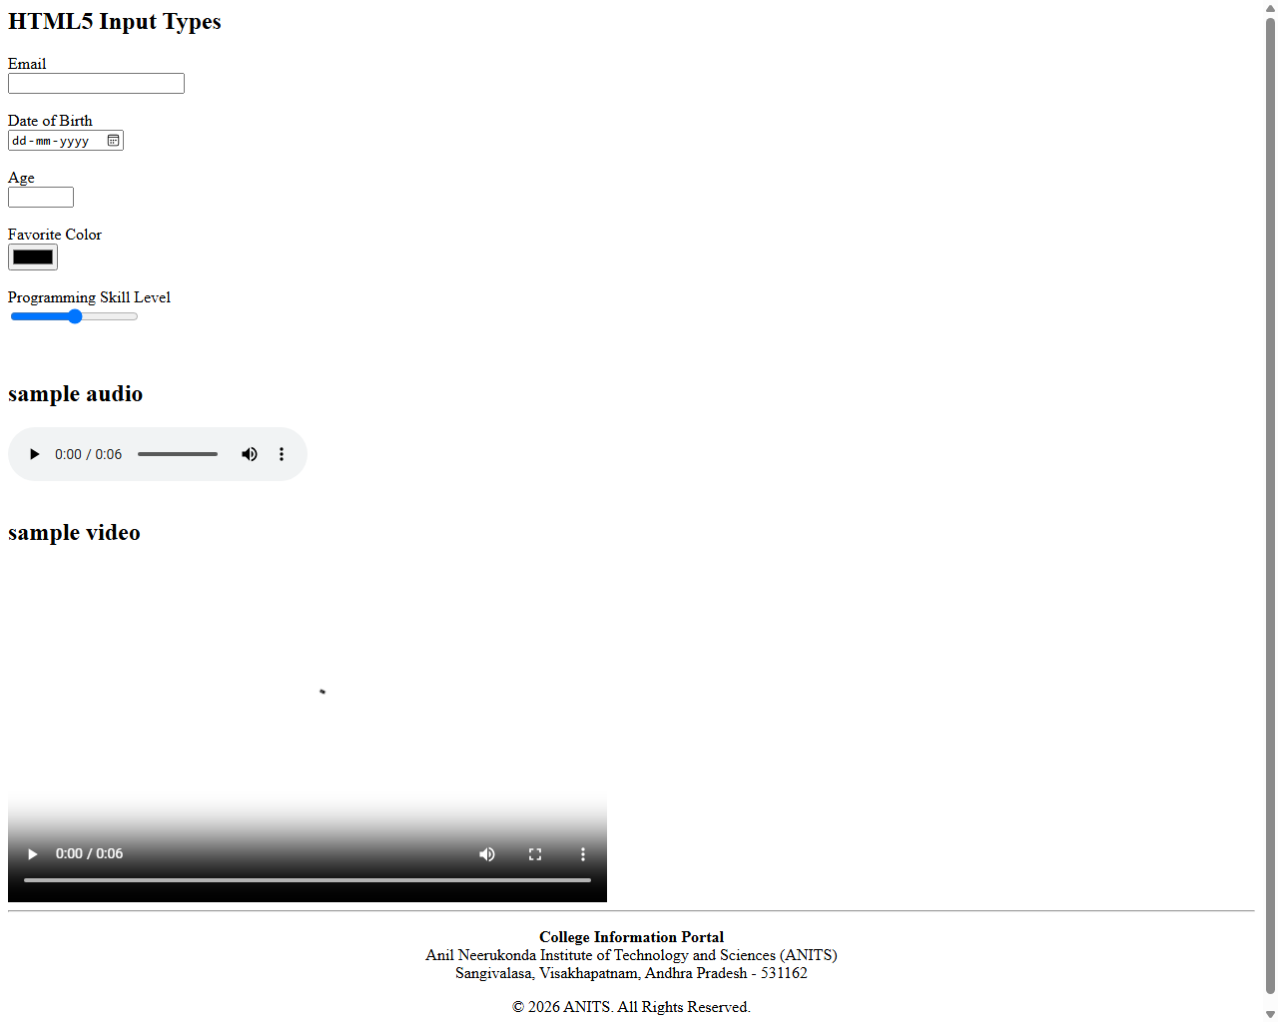

10. RESULT
Thus, the College Information Portal was successfully designed, developed, and verified using pure semantic HTML5 tags across all four parts. Document structure, text formatting, tabular data, user registration forms, and multimedia integration functioned accurately across all test cases.

